
Company
Logotype

Cone Beam Computed Tomography- Report



Porur Dental X-rays & CBCT

Patient Name : Mrs. Kanchana | Date of Report : 22.07.2024
Age/ Gender : 60 years/ Female | Region of Interest : CBCT Anterior Maxilla
Referring doctor: Dr. Ram Sabarish | Indication : Discoloured tooth 11, 12
Clinical Notes: Nil
PATIENT INFORMATION

CBCT Anterior Maxilla provided
CBCT – IMAGE DETAILS

RADIOGRAPHIC INTERPRETATION

- In relation to the periapical aspect of 11, 12 presence of a diffuse periapical hypodense area measuring 5.79 x 3.62 x 4.51 mm in 11 and 4.78 x 3.39 x 3.69 mm in 12, surrounded by a diffuse margin is evident.
- The hypodense area appears to cause extreme thinning of the labial cortical plate is evident.

RADIOGRAPHIC IMPRESSION

- Periapical pathology in relation to 11, 12.


Kindly correlate with clinical and histopathological features

IMAGES FOR REFERENCE

RECONSTRUCTED PANORAMIC VIEW

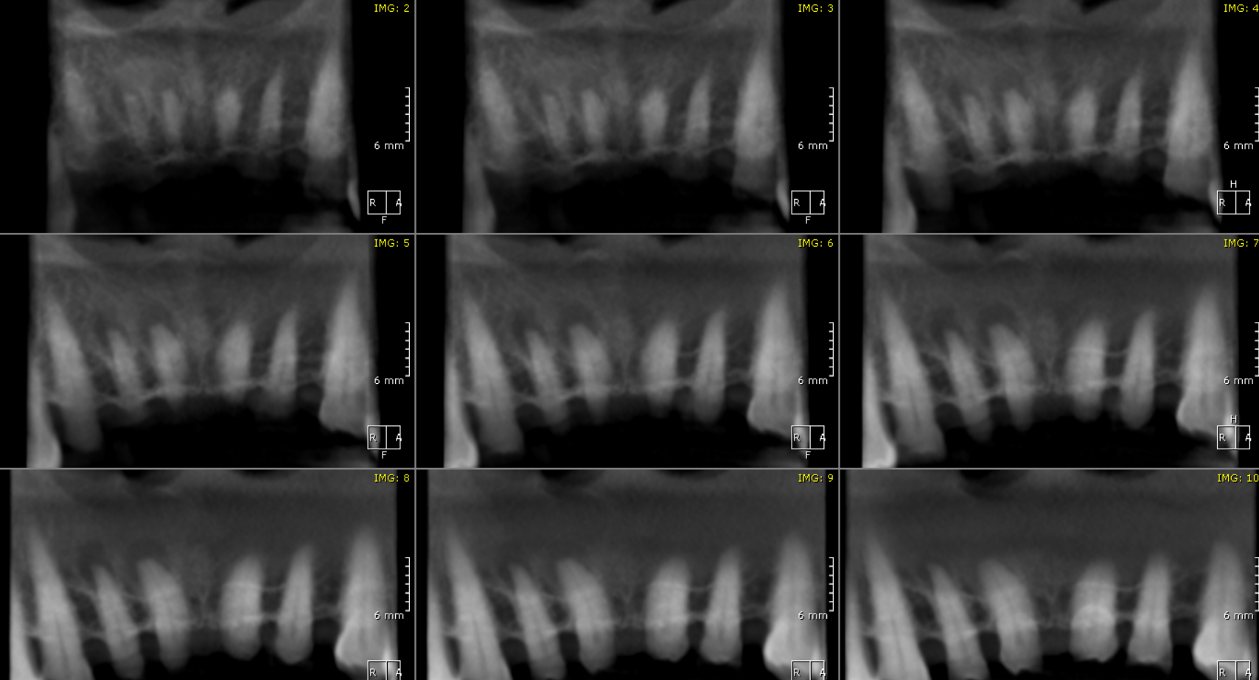

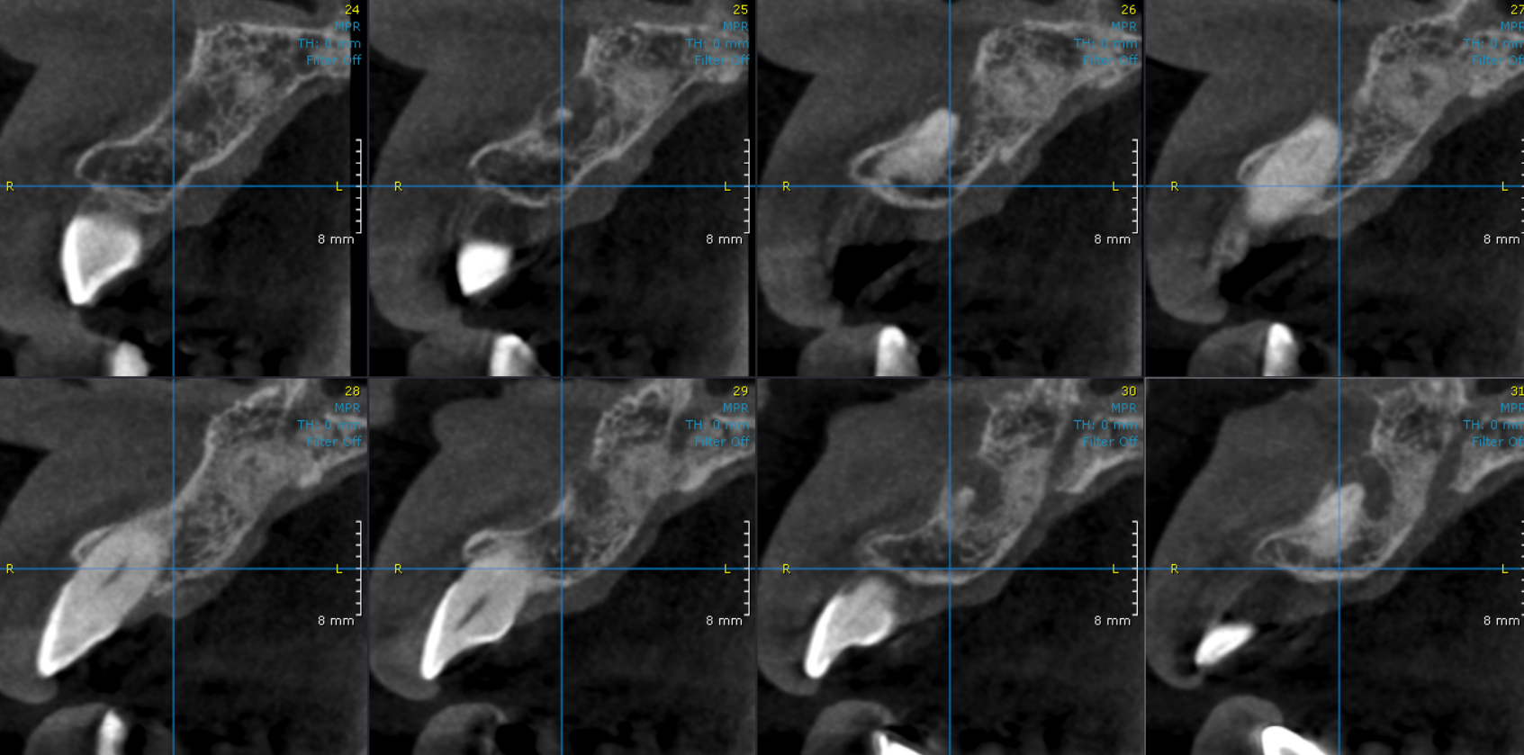
CROSS SECTIONAL IMAGES FOR REFERENCE

3-DIMENSIONAL VIEW

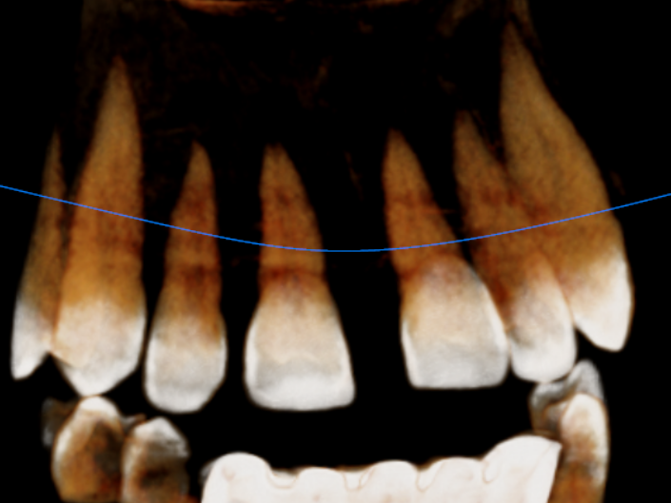

**** End of report ****

